**Node Tutorial**

**An overview of Node.js**

▪**Building and installing Node.js**

▪**Developing for Node with Cloud9 IDE**

▪**An introduction to Node’s event loop**

▪**Writing code with callbacks**

# An overview of Node.js

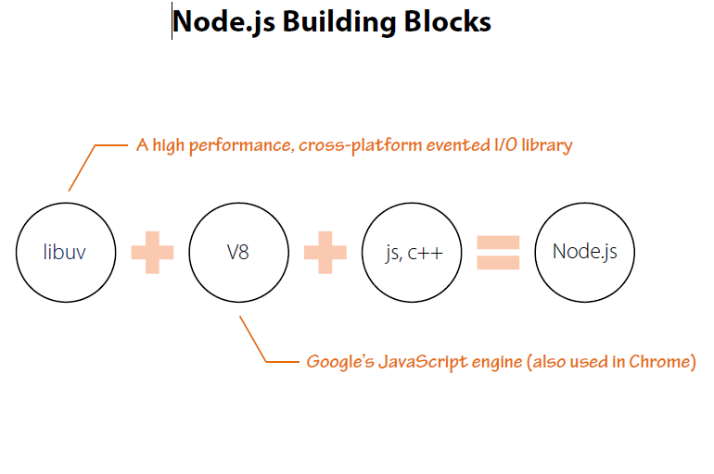

# Building and installing Node.js

[**http://nodejs.org/download/**](http://nodejs.org/download/)

**Installers available for Windows & Mac OS X**

* 1. ▪**Binaries available for Windows, Mac, Linux and SunOS** Also available via many Linux package managers
  2. ▪**Source code also available**

1. nvm install 0.8.14
2. ▪nvm use 0.6.19
3. ▪nvm alias default 0.8.14

# Developing for Node with Vscode

# An introduction to Node’s event loop

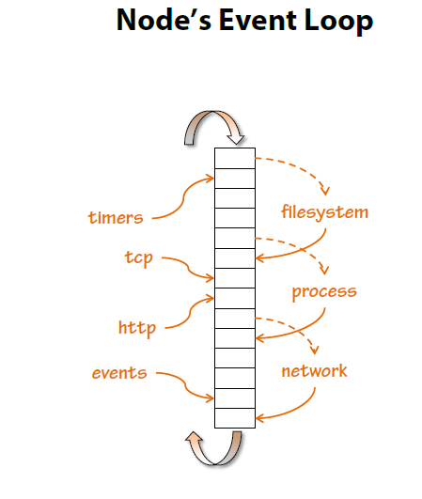

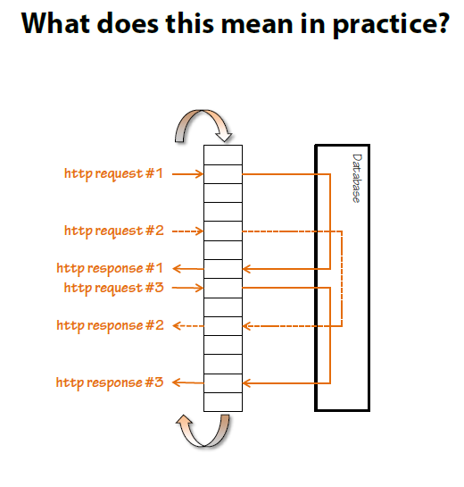

# Writing code with callbacks

**A typical approach / blocking code**

var conn = getDbConnection(connectionString);

var stmt = conn.createStatement();

var results = stmt.executeQuery(sqlQuery);

for (var i=0; i<results.length; i++) {

// print results[i];

}

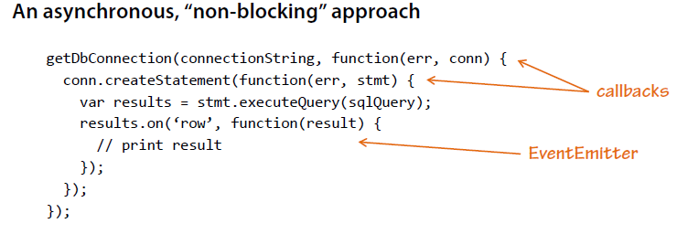

**Coding for asynchrony with callbacks**

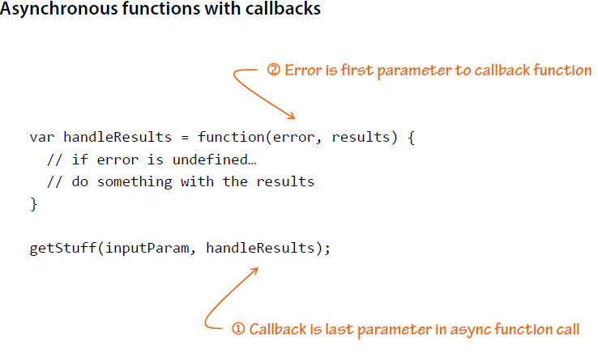

**Anonymous Functions and Closures**

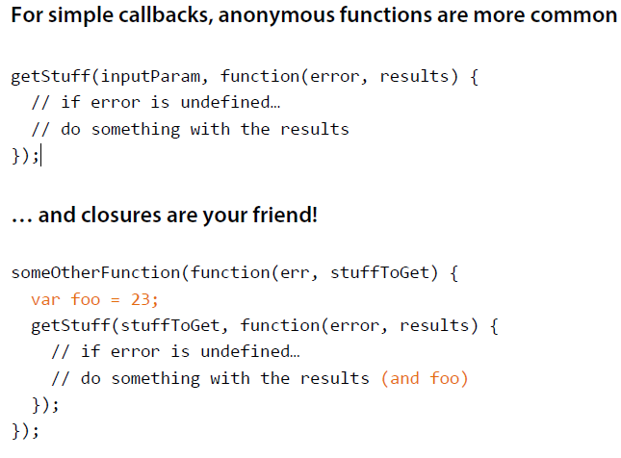

**“Christmas tree” effect!**

asyncFunction1(inputParam, function(err, results1) {

asyncFunction2(results1, function (err, results2) {

asyncFunction3(results2, function (err, results3) {

asyncFunction4(results3, function (err, results4) {

asyncFunction5(results4, function (err, results5) {

// and so on…

});

});

});

});

});

